

**06**

**Design of each form in the** **application**

**&code implementation ….**

**Login Page**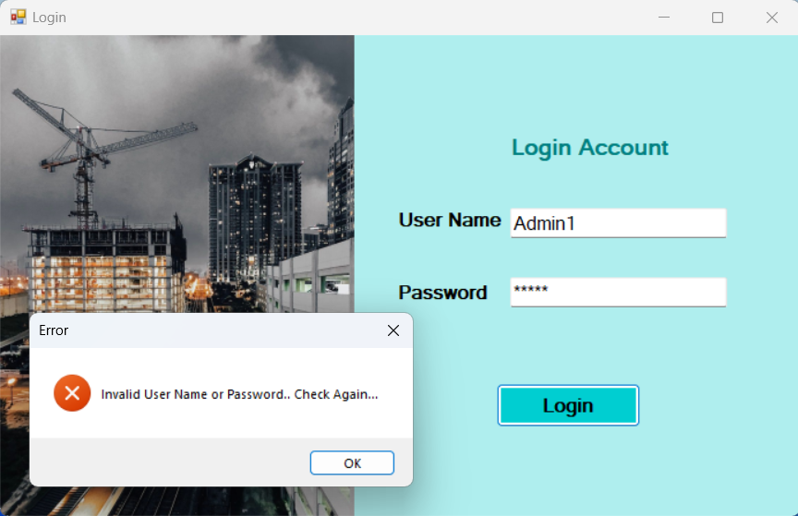

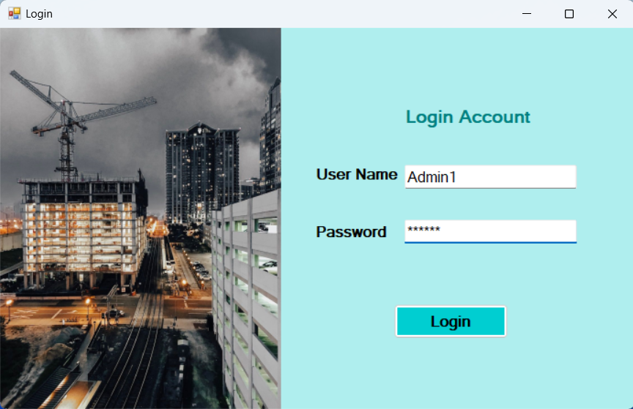

using System;

using System.Collections.Generic;

using System.ComponentModel;

using System.Data;

using System.Drawing;

using System.Linq;

using System.Text;

using System.Threading.Tasks;

using System.Windows.Forms;

namespace ProjectManagementSystem

{

public partial class Login : Form

{

public Login()

{

InitializeComponent();

}

private void btnLogin_Click(object sender, EventArgs e)

{

if (textUser.Text == "Admin1" && textPassword.Text == "admin1") {

Home h1 = new Home();

this.Hide();

h1.ShowDialog();

this.Close();

}

else

{

MessageBox.Show("Invalid User Name or Password.. Check Again...","Error", MessageBoxButtons.OK ,MessageBoxIcon.Error);

textUser.Clear();

textPassword.Clear();

};

}

}

}

**==============================================================================**

**Dashboard**



using System;

using System.Collections.Generic;

using System.ComponentModel;

using System.Data;

using System.Drawing;

using System.Linq;

using System.Text;

using System.Threading.Tasks;

using System.Windows.Forms;

namespace ProjectManagementSystem

{

public partial class Home : Form

{

public Home()

{

InitializeComponent();

}

private void button2_Click(object sender, EventArgs e)

{

button1.BackColor = Color.Cyan;

button2.BackColor = Color.Coral;

button3.BackColor = Color.Cyan;

button4.BackColor = Color.Cyan;

button5.BackColor = Color.Cyan;

pictureBox2.Visible = false;

Employees e1 = new Employees();

e1.MdiParent = this;

e1.Dock = DockStyle.Fill;

e1.Show();

}

private void button1_Click(object sender, EventArgs e)

{

button1.BackColor = Color.Coral;

button2.BackColor = Color.Cyan;

button3.BackColor = Color.Cyan;

button4.BackColor = Color.Cyan;

button5.BackColor = Color.Cyan;

pictureBox2.Visible = false;

Projects p1 = new Projects();

p1.MdiParent = this;

p1.Dock = DockStyle.Fill;

p1.Show();

}

private void panel3_Paint(object sender, PaintEventArgs e)

{

}

private void Home_Load(object sender, EventArgs e)

{

date.Text = DateTime.Now.ToString("yyyy-MM-dd");

}

private void button5_Click(object sender, EventArgs e)

{

button1.BackColor = Color.Cyan;

button2.BackColor = Color.Cyan;

button3.BackColor = Color.Cyan;

button4.BackColor = Color.Cyan;

button5.BackColor = Color.Coral;

pictureBox2.Visible = false;

Progress p2 = new Progress();

p2.MdiParent = this;

p2.Dock = DockStyle.Fill;

p2.Show();

}

public void timer5_Tick(object sender, EventArgs e)

{

// Update the label with the current date and time

}

private void panel2_Paint(object sender, PaintEventArgs e)

{

}

private void button3_Click(object sender, EventArgs e)

{

button1.BackColor = Color.Cyan;

button2.BackColor = Color.Cyan;

button3.BackColor = Color.Coral;

button4.BackColor = Color.Cyan;

button5.BackColor = Color.Cyan;

pictureBox2.Visible = false;

Labour l1 = new Labour();

l1.MdiParent = this;

l1.Dock = DockStyle.Fill;

l1.Show();

}

private void button4_Click(object sender, EventArgs e)

{

button1.BackColor = Color.Cyan;

button2.BackColor = Color.Cyan;

button3.BackColor = Color.Cyan;

button4.BackColor = Color.Coral;

button5.BackColor = Color.Cyan;

pictureBox2.Visible = false;

Resources r1 = new Resources();

r1.MdiParent = this;

r1.Dock = DockStyle.Fill;

r1.Show();

}

}

}

**==============================================================================**

**Projects Page**

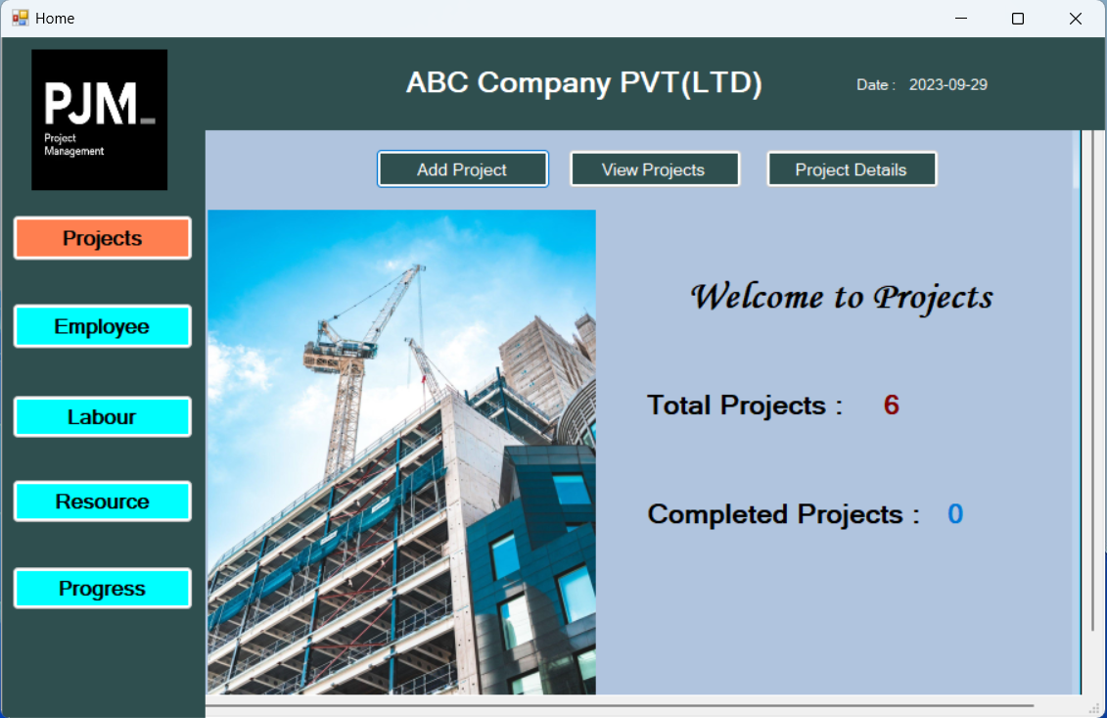

using System;

using System.Collections.Generic;

using System.ComponentModel;

using System.Data;

using System.Data.SqlClient;

using System.Drawing;

using System.Linq;

using System.Text;

using System.Threading.Tasks;

using System.Windows.Forms;

namespace ProjectManagementSystem

{

public partial class Projects : Form

{

public Projects()

{

InitializeComponent();

}

private void label1_Click(object sender, EventArgs e)

{

}

private void viewProjectsToolStripMenuItem_Click(object sender, EventArgs e)

{

}

private void newToolStripMenuItem_Click(object sender, EventArgs e)

{

}

private void addNewToolStripMenuItem_Click(object sender, EventArgs e)

{

}

private void projCount_Click(object sender, EventArgs e)

{

}

private void label2_Click(object sender, EventArgs e)

{

}

private void Projects_Load(object sender, EventArgs e)

{

SqlConnection conn = new SqlConnection("Data Source=localhost\\SQLEXPRESS;Initial Catalog=PMSDB;Integrated Security=True");

conn.Open();

SqlCommand cmd1 = new SqlCommand("Select Count(ProjectId) From Projects", conn);

int projectCount = (int)cmd1.ExecuteScalar();

total.Text = projectCount.ToString();

SqlCommand cmd2 = new SqlCommand("Select Count(ProjectId) From Projects Where (Status = 'Completed' or Status = 'Closed')", conn);

int CompleteCount = (int)cmd2.ExecuteScalar();

complete.Text = CompleteCount.ToString();

conn.Close();

}

private void label3_Click(object sender, EventArgs e)

{

}

private void exitToolStripMenuItem_Click(object sender, EventArgs e)

{

Home h1 = new Home();

this.Hide();

h1.ShowDialog();

this.Close();

}

private void viewAllProjectsToolStripMenuItem_Click(object sender, EventArgs e)

{

}

private void serchProjectToolStripMenuItem_Click(object sender, EventArgs e)

{

}

private void searchToolStripMenuItem_Click(object sender, EventArgs e)

{

}

private void searchProjectsToolStripMenuItem_Click(object sender, EventArgs e)

{

}

private void button1_Click(object sender, EventArgs e)

{

Add_Projects ap1 = new Add_Projects();

ap1.ShowDialog();

}

private void button2_Click(object sender, EventArgs e)

{

View_Projects vp = new View_Projects();

vp.ShowDialog();

}

private void button3_Click(object sender, EventArgs e)

{

Search_Project sp = new Search_Project();

sp.ShowDialog();

}

}

}

**==============================================================================**

**Add Project Form**

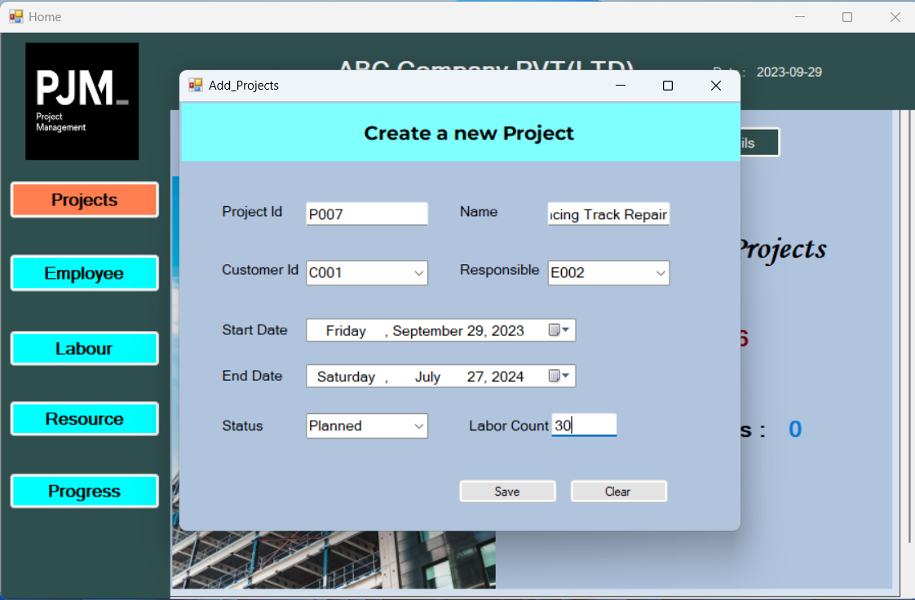

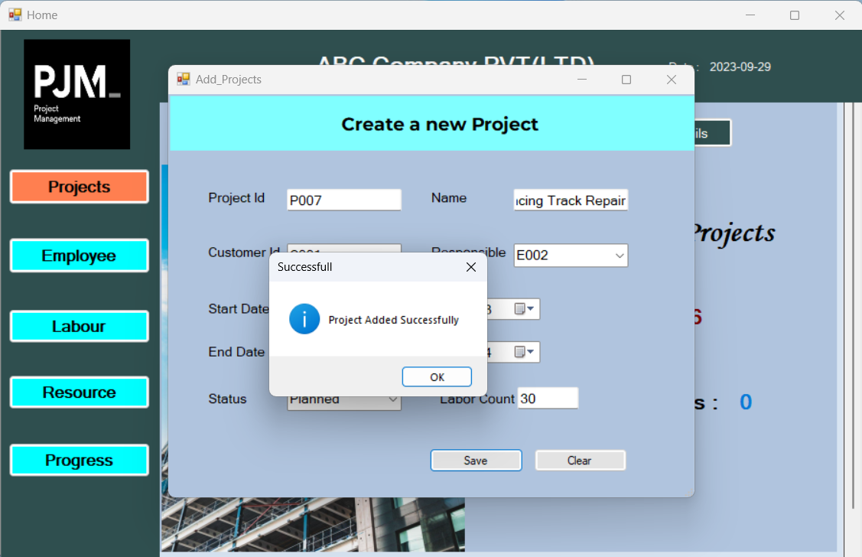

using System;

using System.Collections.Generic;

using System.ComponentModel;

using System.Data;

using System.Data.SqlClient;

using System.Drawing;

using System.Linq;

using System.Text;

using System.Threading.Tasks;

using System.Windows.Forms;

namespace ProjectManagementSystem

{

public partial class Add_Projects : Form

{

public Add_Projects()

{

InitializeComponent();

}

private void button2_Click(object sender, EventArgs e)

{

Projects p1 = new Projects();

this.Hide();

p1.ShowDialog();

this.Close();

}

private void button1_Click(object sender, EventArgs e)

{

SqlConnection conn = new SqlConnection("Data Source=localhost\\SQLEXPRESS;Initial Catalog=PMSDB;Integrated Security=True");

conn.Open();

SqlCommand cmd = new SqlCommand("Insert into Projects values (@ProjectId,@Name,@StartDate,@EndDate,@Responsible,@CustomerId,@LaborCount,@Status)", conn);

cmd.Parameters.AddWithValue("@ProjectId", txtId.Text);

cmd.Parameters.AddWithValue("@Name", txtName.Text);

cmd.Parameters.AddWithValue("@StartDate", DateTime.Parse(date1.Text));

cmd.Parameters.AddWithValue("@EndDate", DateTime.Parse(date2.Text));

cmd.Parameters.AddWithValue("@Responsible", resBox.Text);

cmd.Parameters.AddWithValue("@CustomerId", customerBox.Text);

cmd.Parameters.AddWithValue("@LaborCount", int.Parse(txtLabor.Text));

cmd.Parameters.AddWithValue("@Status", statusBox.Text);

cmd.ExecuteNonQuery();

conn.Close();

MessageBox.Show("Project Added Successfully", "Successfull", MessageBoxButtons.OK, MessageBoxIcon.Information);

txtId.Clear();

txtName.Clear();

date1.Text = DateTime.Now.ToString();

date2.Text = DateTime.Now.ToString();

resBox.Text = "";

customerBox.Text = "";

txtLabor.Clear();

statusBox.Text = "";

}

private void button3_Click(object sender, EventArgs e)

{

txtId.Clear();

txtName.Clear();

date1.Text = DateTime.Now.ToString();

date2.Text = DateTime.Now.ToString();

resBox.Text = "";

customerBox.Text = "";

txtLabor.Clear();

statusBox.Text = "";

}

private void Add_Projects_Load(object sender, EventArgs e)

{

SqlConnection conn = new SqlConnection("Data Source=localhost\\SQLEXPRESS;Initial Catalog=PMSDB;Integrated Security=True");

conn.Open();

SqlCommand cmd1 = new SqlCommand("Select EmployeeId From EmpTemp Where Role = 'Manager'", conn);

List<string> EmpIds = new List<string>();

using (SqlDataReader reader1 = cmd1.ExecuteReader())

{

while (reader1.Read())

{

string empId = reader1["EmployeeId"].ToString(); // Assuming ProjectId is a string

EmpIds.Add(empId);

}

}

// Convert the list to an array if needed

string[] empIdsArray = EmpIds.ToArray();

// Populate a ListBox or another control with the array

resBox.Items.AddRange(empIdsArray);

SqlCommand cmd2 = new SqlCommand("Select CustomerId From Customer", conn);

List<string> custIds = new List<string>();

using (SqlDataReader reader2 = cmd2.ExecuteReader())

{

while (reader2.Read())

{

string custId = reader2["CustomerId"].ToString(); // Assuming ProjectId is a string

custIds.Add(custId);

}

}

// Convert the list to an array if needed

string[] custIdsArray = custIds.ToArray();

// Populate a ListBox or another control with the array

customerBox.Items.AddRange(custIdsArray);

conn.Close();

}

}

}

**==============================================================================**

**View Project Form**

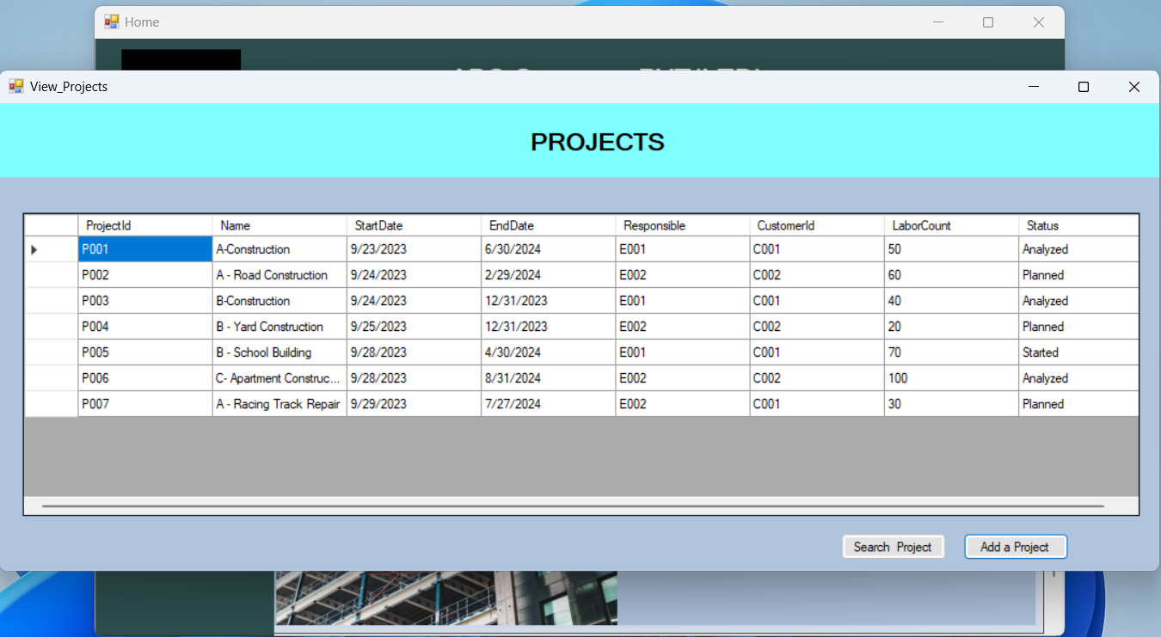

using System;

using System.Collections.Generic;

using System.ComponentModel;

using System.Data;

using System.Drawing;

using System.Linq;

using System.Text;

using System.Threading.Tasks;

using System.Windows.Forms;

namespace ProjectManagementSystem

{

public partial class View_Projects : Form

{

public View_Projects()

{

InitializeComponent();

}

private void button1_Click(object sender, EventArgs e)

{

Add_Projects ap1 = new Add_Projects();

ap1.ShowDialog();

}

private void button2_Click(object sender, EventArgs e)

{

Projects p1 = new Projects();

this.Hide();

p1.ShowDialog();

this.Close();

}

private void label1_Click(object sender, EventArgs e)

{

}

private void View_Projects_Load(object sender, EventArgs e)

{

this.sqlDataAdapter1.Fill(this.projectsSet1.Projects);

}

private void button2_Click_1(object sender, EventArgs e)

{

Search_Project sp1 = new Search_Project();

sp1.ShowDialog();

}

}

}

**==============================================================================**

**Project Details Form**

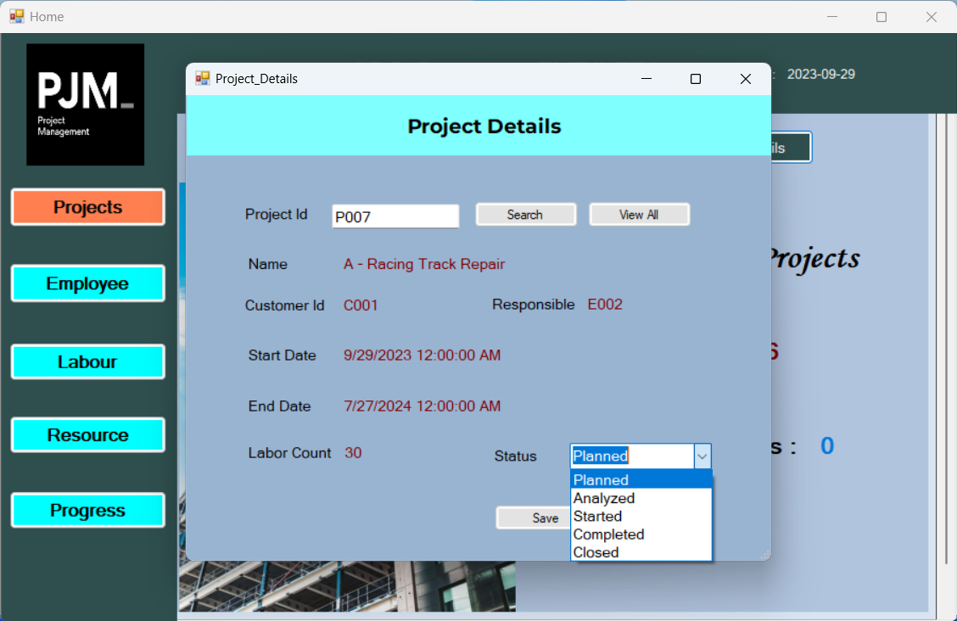

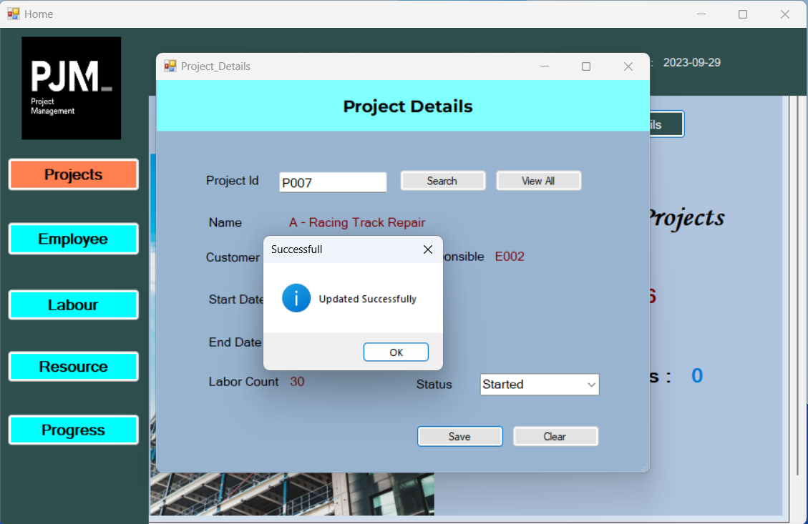

using System;

using System.Collections.Generic;

using System.ComponentModel;

using System.Data;

using System.Drawing;

using System.Linq;

using System.Text;

using System.Threading.Tasks;

using System.Windows.Forms;

using System.Data.OleDb;

using System.Data.SqlClient;

namespace ProjectManagementSystem

{

public partial class Search_Project : Form

{

public Search_Project()

{

InitializeComponent();

}

private void button2_Click(object sender, EventArgs e)

{

Home h1 = new Home();

this.Hide();

h1.ShowDialog();

this.Close();

}

private void button1_Click(object sender, EventArgs e)

{

SqlConnection conn = new SqlConnection("Data Source=localhost\\SQLEXPRESS;Initial Catalog=PMSDB;Integrated Security=True");

conn.Open();

SqlCommand cmd = new SqlCommand("Select * from Projects where ProjectId=@id", conn);

cmd.Parameters.AddWithValue("id", txtId.Text);

SqlDataReader reader1;

reader1 = cmd.ExecuteReader();

if(reader1.Read())

{

txtName.Text = reader1["Name"].ToString();

Responsible.Text = reader1["Responsible"].ToString();

CustomerId.Text = reader1["CustomerId"].ToString();

StartDate.Text = reader1["StartDate"].ToString();

EndDate.Text = reader1["EndDate"].ToString();

LaborCount.Text = reader1["LaborCount"].ToString();

statusBox.Text = reader1["Status"].ToString();

}

else

{

MessageBox.Show("Invalid Project ID Check Again..", "Data Not Found", MessageBoxButtons.OK, MessageBoxIcon.Error);

}

}

private void button3_Click(object sender, EventArgs e)

{

txtId.Clear();

txtName.Text = "";

Responsible.Text = "";

CustomerId.Text = "";

StartDate.Text = "";

EndDate.Text = "";

LaborCount.Text = "";

statusBox.Text = "";

}

private void button2_Click_1(object sender, EventArgs e)

{

SqlConnection conn = new SqlConnection("Data Source=localhost\\SQLEXPRESS;Initial Catalog=PMSDB;Integrated Security=True");

conn.Open();

SqlCommand cmd = new SqlCommand("update Projects set Status=@Status Where ProjectId=@id ", conn);

cmd.Parameters.AddWithValue("id", txtId.Text);

cmd.Parameters.AddWithValue("@Status", statusBox.Text);

cmd.ExecuteNonQuery();

conn.Close();

MessageBox.Show("Updated Successfully", "Successfull", MessageBoxButtons.OK, MessageBoxIcon.Information);

txtId.Clear();

txtName.Text = "";

Responsible.Text = "";

CustomerId.Text = "";

StartDate.Text = "";

EndDate.Text = "";

LaborCount.Text = "";

statusBox.Text = "";

}

private void button4_Click(object sender, EventArgs e)

{

View_Projects vp1 = new View_Projects();

this.Hide();

vp1.ShowDialog();

this.Close();

}

}

}

**Employee Page**

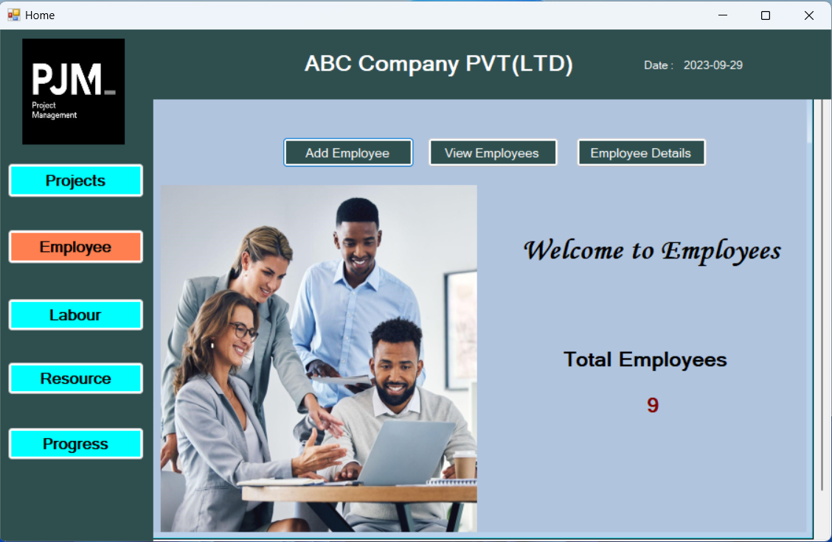

using System;

using System.Collections.Generic;

using System.ComponentModel;

using System.Data;

using System.Data.SqlClient;

using System.Drawing;

using System.Linq;

using System.Text;

using System.Threading.Tasks;

using System.Windows.Forms;

namespace ProjectManagementSystem

{

public partial class Employees : Form

{

public Employees()

{

InitializeComponent();

}

private void Employees_Load(object sender, EventArgs e)

{

SqlConnection conn = new SqlConnection("Data Source=localhost\\SQLEXPRESS;Initial Catalog=PMSDB;Integrated Security=True");

conn.Open();

SqlCommand cmd1 = new SqlCommand("Select Count(EmployeeId) From EmpTemp", conn);

int empCount = (int)cmd1.ExecuteScalar();

total.Text = empCount.ToString();

conn.Close();

}

private void button1_Click(object sender, EventArgs e)

{

Add_Employee ae1 = new Add_Employee();

ae1.ShowDialog();

}

private void button3_Click(object sender, EventArgs e)

{

Employee_Details ed1 = new Employee_Details();

ed1.ShowDialog();

}

private void button2_Click(object sender, EventArgs e)

{

View_Employees ve1 = new View_Employees();

ve1.ShowDialog();

}

}

}

**==============================================================================**

**Add Employee Form**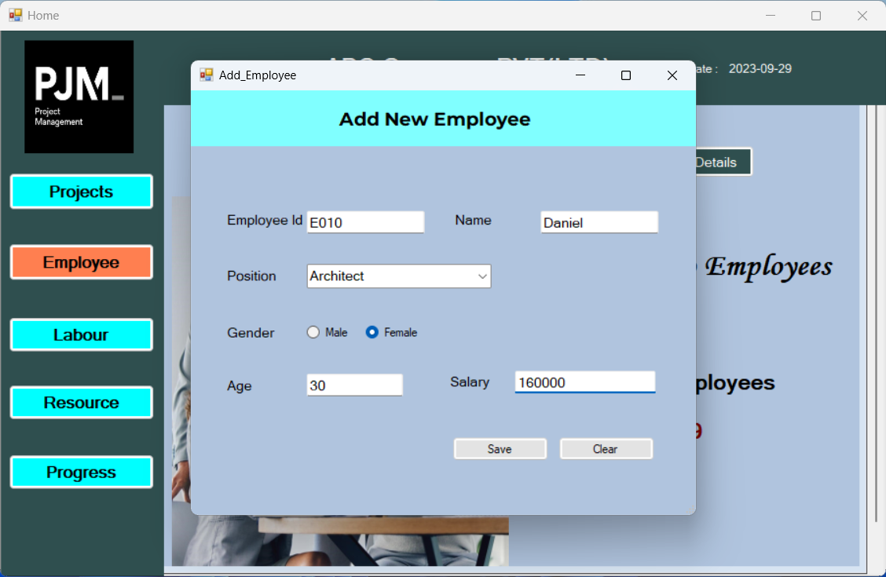

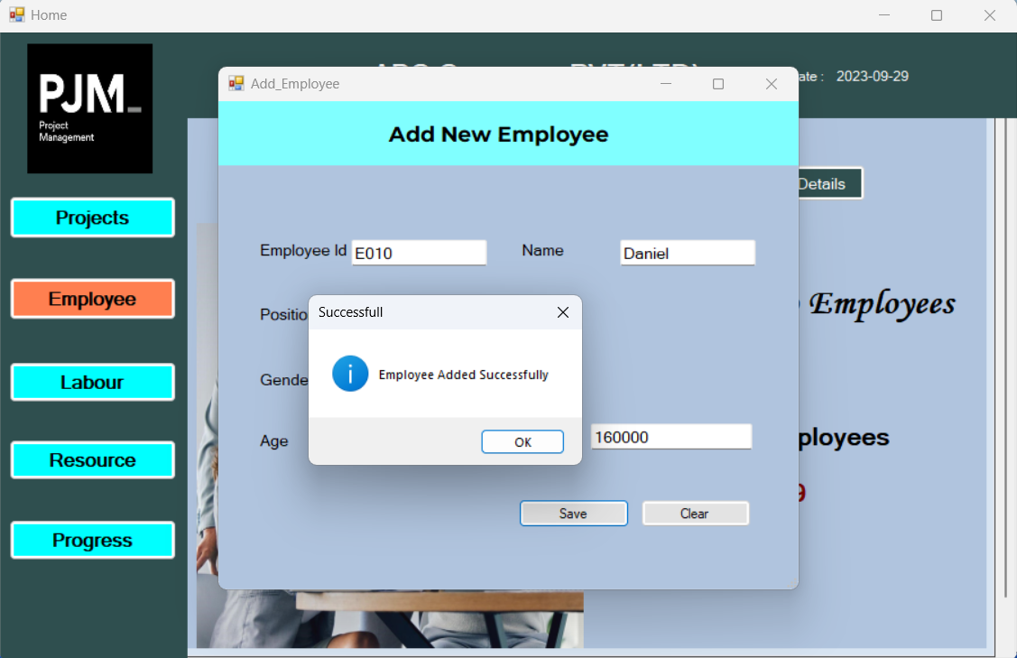

using System;

using System.Collections.Generic;

using System.ComponentModel;

using System.Data;

using System.Data.SqlClient;

using System.Drawing;

using System.Linq;

using System.Text;

using System.Threading.Tasks;

using System.Windows.Forms;

namespace ProjectManagementSystem

{

public partial class Add_Employee : Form

{

public Add_Employee()

{

InitializeComponent();

}

private void Add_Employee_Load(object sender, EventArgs e)

{

}

private void button3_Click(object sender, EventArgs e)

{

txtId.Clear();

txtName.Clear();

roleBox.Text = "";

radioButton1.Checked = false;

radioButton2.Checked = false;

age.Clear();

empSalary.Clear();

}

private void button1_Click(object sender, EventArgs e)

{

SqlConnection conn = new SqlConnection("Data Source=localhost\\SQLEXPRESS;Initial Catalog=PMSDB;Integrated Security=True");

conn.Open();

SqlCommand cmd = new SqlCommand("Insert into EmpTemp values (@EmployeeId,@EmpName,@Role,@Age,@Gender,@Salary)", conn);

cmd.Parameters.AddWithValue("@EmployeeId", txtId.Text);

cmd.Parameters.AddWithValue("@EmpName", txtName.Text);

cmd.Parameters.AddWithValue("@Role", roleBox.Text);

cmd.Parameters.AddWithValue("@Age", int.Parse(age.Text));

if (radioButton1.Checked)

{

cmd.Parameters.AddWithValue("@Gender", "Male");

}

if (radioButton2.Checked)

{

cmd.Parameters.AddWithValue("@Gender", "Female");

}

cmd.Parameters.AddWithValue("@Salary", int.Parse(empSalary.Text));

cmd.ExecuteNonQuery();

conn.Close();

MessageBox.Show("Employee Added Successfully", "Successfull", MessageBoxButtons.OK, MessageBoxIcon.Information);

txtId.Clear();

txtName.Clear();

roleBox.Text = "";

radioButton1.Checked = false;

radioButton2.Checked = false;

age.Clear();

empSalary.Clear();

this.Refresh();

}

private void txtLabor_TextChanged(object sender, EventArgs e)

{

}

}

}

**==============================================================================**

**View Employee Form**

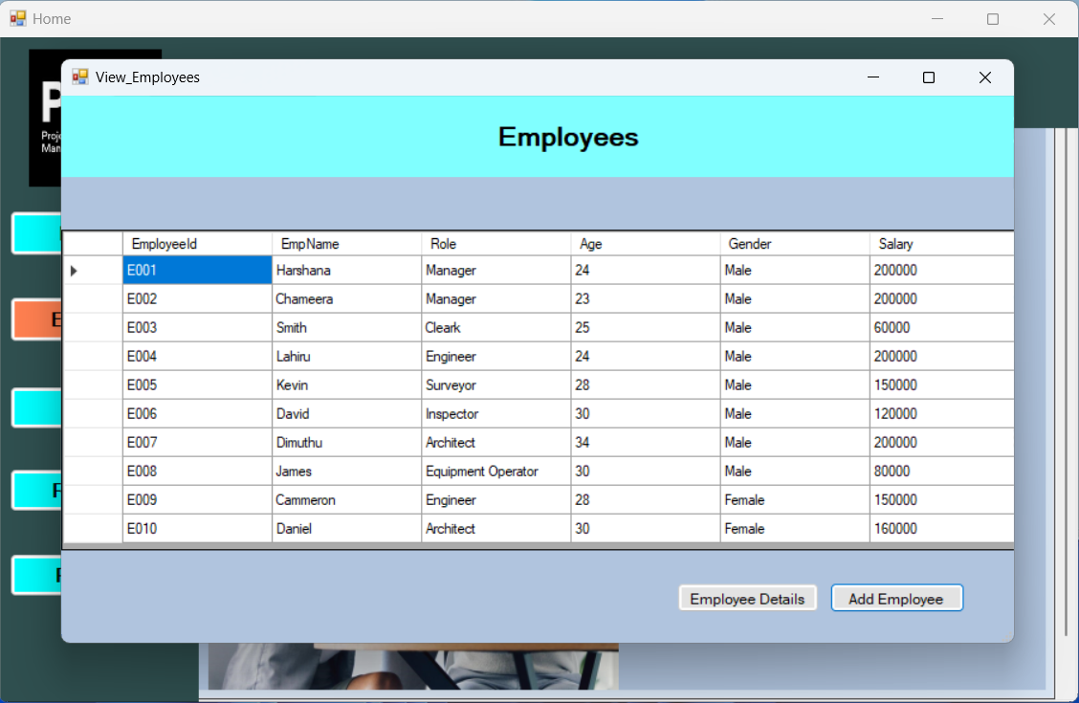

using System;

using System.Collections.Generic;

using System.ComponentModel;

using System.Data;

using System.Drawing;

using System.Linq;

using System.Text;

using System.Threading.Tasks;

using System.Windows.Forms;

namespace ProjectManagementSystem

{

public partial class View_Employees : Form

{

public View_Employees()

{

InitializeComponent();

}

private void button1_Click(object sender, EventArgs e)

{

Add_Employee ae1 = new Add_Employee();

ae1.ShowDialog();

}

private void button2_Click(object sender, EventArgs e)

{

Employee_Details ed1 = new Employee_Details();

ed1.ShowDialog();

}

private void View_Employees_Load(object sender, EventArgs e)

{

this.sqlDataAdapter1.Fill(this.employeeSet.EmpTemp);

}

}

}

**==============================================================================**

**Employee Details Form**

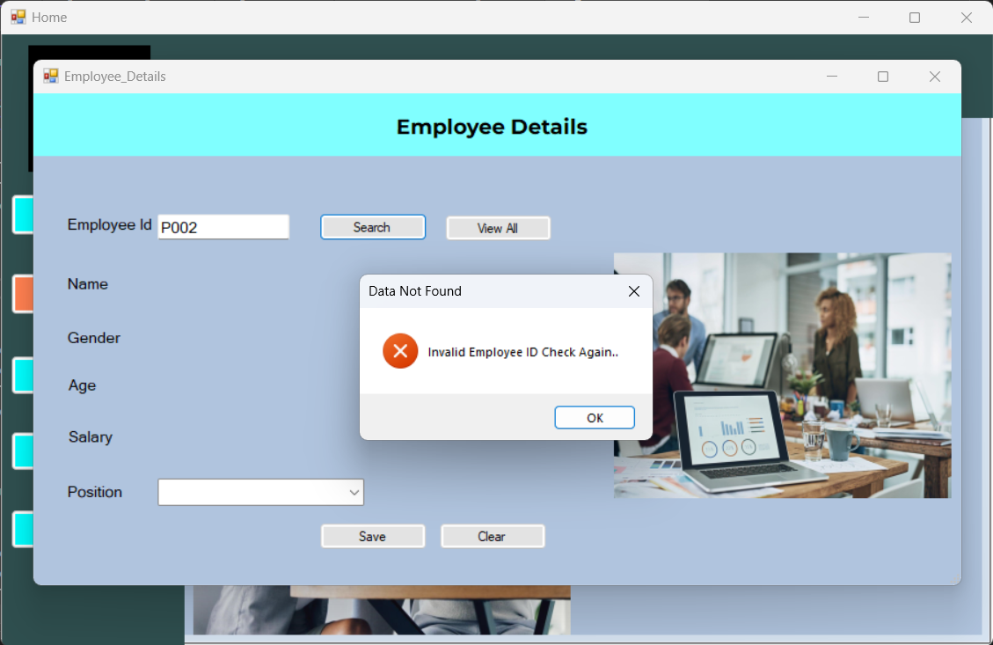

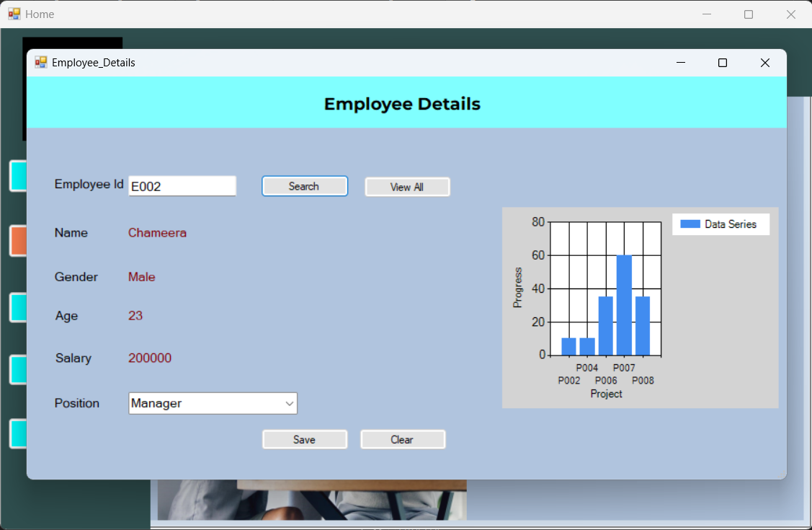

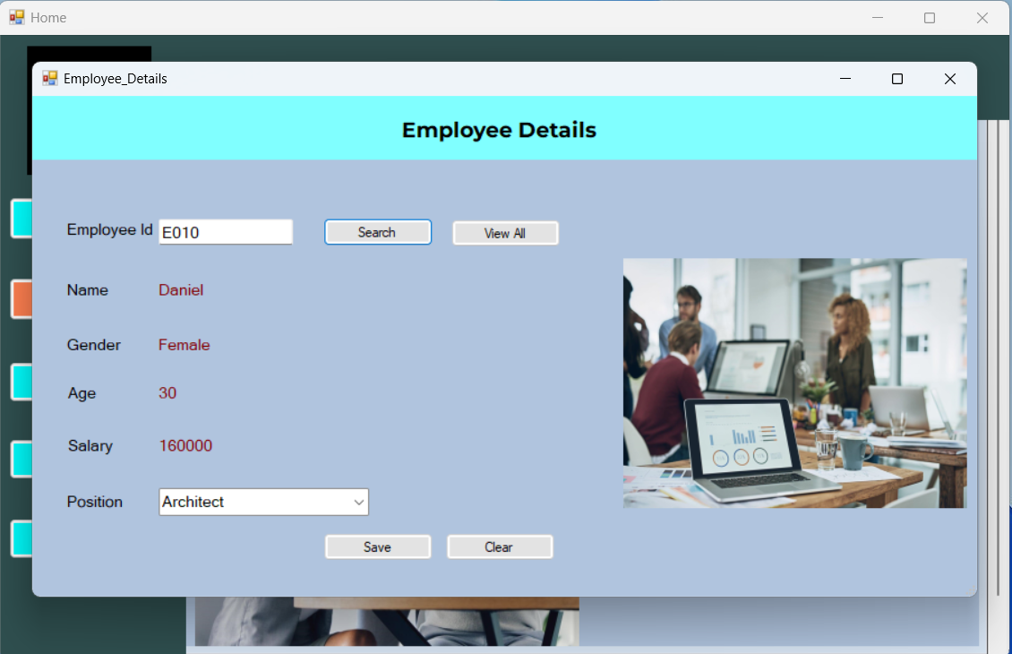

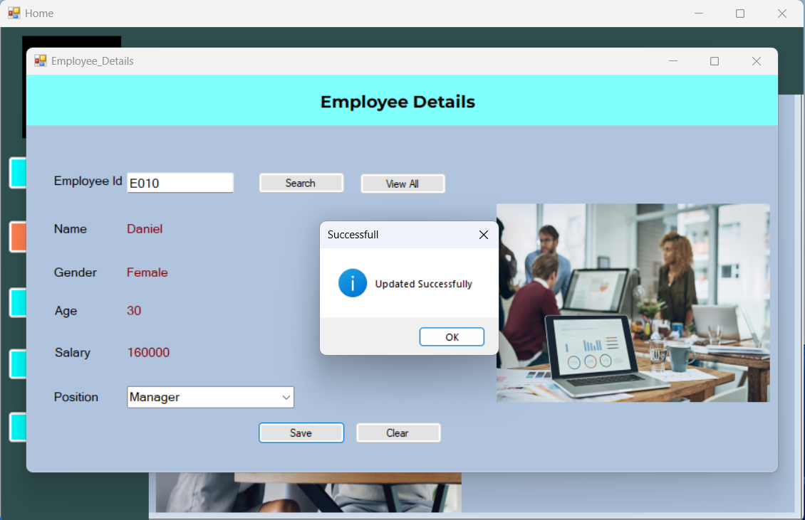

using System;

using System.Collections.Generic;

using System.ComponentModel;

using System.Data;

using System.Data.SqlClient;

using System.Drawing;

using System.Linq;

using System.Runtime.InteropServices.ComTypes;

using System.Text;

using System.Threading.Tasks;

using System.Windows.Forms;

using System.Windows.Forms.DataVisualization.Charting;

using System.Xml.Linq;

namespace ProjectManagementSystem

{

public partial class Employee_Details : Form

{

public Employee_Details()

{

InitializeComponent();

}

private void button2_Click(object sender, EventArgs e)

{

SqlConnection conn = new SqlConnection("Data Source=localhost\\SQLEXPRESS;Initial Catalog=PMSDB;Integrated Security=True");

conn.Open();

SqlCommand cmd = new SqlCommand("Select * from EmpTemp where EmployeeId=@id", conn);

cmd.Parameters.AddWithValue("id", txtId.Text);

SqlDataReader reader1;

reader1 = cmd.ExecuteReader();

if (reader1.Read())

{

empName.Text = reader1["EmpName"].ToString();

roleBox.Text = reader1["Role"].ToString();

empAge.Text = reader1["Age"].ToString();

empGender.Text = reader1["Gender"].ToString();

Salary.Text = reader1["Salary"].ToString();

}

else

{

MessageBox.Show("Invalid Employee ID Check Again..", "Data Not Found", MessageBoxButtons.OK, MessageBoxIcon.Error);

}

reader1.Close();

conn.Close();

if (roleBox.Text == "Manager")

{

pictureBox1.Visible = false;

// Create a series

Series series = new Series("Data Series");

series.ChartType = SeriesChartType.Column;

chart1.Series.Add(series);

// Connect to the database

string connectionString = "Data Source=localhost\\SQLEXPRESS;Initial Catalog=PMSDB;Integrated Security=True";

using (SqlConnection connection = new SqlConnection(connectionString))

{

connection.Open();

SqlCommand cmd1 = new SqlCommand("SELECT ProjectId, Status FROM Projects Where Responsible=@eId", connection);

cmd1.Parameters.AddWithValue("eId", txtId.Text);

// Read data from the database and add data points to the series

SqlDataReader reader2 = cmd1.ExecuteReader();

while (reader2.Read())

{

string Id = reader2["ProjectId"].ToString();

int value = 0;

switch (reader2["Status"].ToString())

{

case "Planned":

value = 10;

break;

case "Analyzed":

value = 35;

break;

case "Started":

value = 60;

break;

case "Completed":

value = 80;

break;

case "Closed":

value = 100;

break;

// Handle other statuses as needed

}

// Add data points based on the "Name" column value

series.Points.AddXY(Id, value);

// Label the X-axis directly

chart1.ChartAreas[0].AxisX.Title = "Project";

// Label the Y-axis directly

chart1.ChartAreas[0].AxisY.Title = "Progress";

// Refresh the chart to display the changes

chart1.Refresh();

}

}

}

else

{

pictureBox1.Visible = true;

}

}

private void button1_Click(object sender, EventArgs e)

{

SqlConnection conn = new SqlConnection("Data Source=localhost\\SQLEXPRESS;Initial Catalog=PMSDB;Integrated Security=True");

conn.Open();

SqlCommand cmd = new SqlCommand("update EmpTemp set Role=@Role Where EmployeeId=@id ", conn);

cmd.Parameters.AddWithValue("id", txtId.Text);

cmd.Parameters.AddWithValue("@Role", roleBox.Text);

cmd.ExecuteNonQuery();

conn.Close();

MessageBox.Show("Updated Successfully", "Successfull", MessageBoxButtons.OK, MessageBoxIcon.Information);

txtId.Clear();

empName.Text = "";

empAge.Text = "";

empGender.Text = "";

roleBox.Text = "";

Salary.Text = "";

pictureBox1.Visible = true;

}

private void button3_Click(object sender, EventArgs e)

{

txtId.Clear();

empName.Text = "";

empAge.Text = "";

empGender.Text = "";

roleBox.Text = "";

Salary.Text = "";

pictureBox1.Visible = true;

}

private void button4_Click(object sender, EventArgs e)

{

View_Employees ve1 = new View_Employees();

ve1.ShowDialog();

}

}

}

**==============================================================================**

**Labour Page**

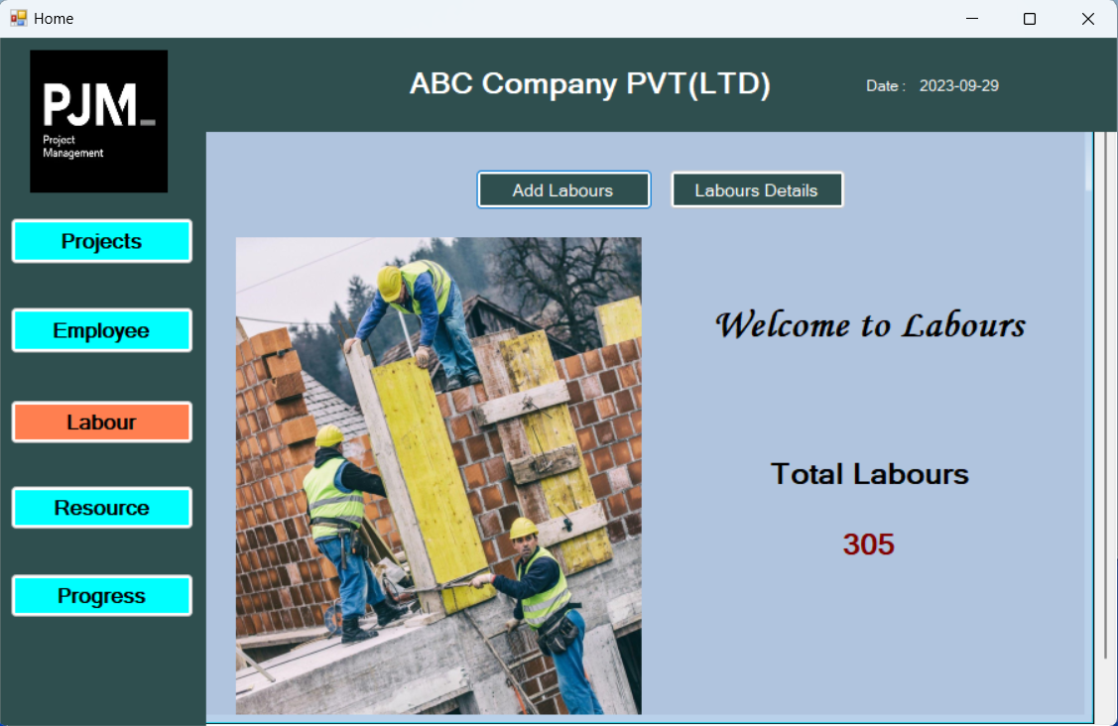

using System;

using System.Collections.Generic;

using System.ComponentModel;

using System.Data;

using System.Data.SqlClient;

using System.Drawing;

using System.Linq;

using System.Text;

using System.Threading.Tasks;

using System.Windows.Forms;

namespace ProjectManagementSystem

{

public partial class Labour : Form

{

public Labour()

{

InitializeComponent();

}

private void Labour_Load(object sender, EventArgs e)

{

SqlConnection conn = new SqlConnection("Data Source=localhost\\SQLEXPRESS;Initial Catalog=PMSDB;Integrated Security=True");

conn.Open();

SqlCommand cmd1 = new SqlCommand("Select SUM(Count) From Labours", conn);

int lbrCount = (int)cmd1.ExecuteScalar();

total.Text = lbrCount.ToString();

conn.Close();

}

private void button1_Click(object sender, EventArgs e)

{

Add_Labours ae1 = new Add_Labours();

ae1.ShowDialog();

}

private void button2_Click(object sender, EventArgs e)

{

Labour_Details ld1 = new Labour_Details();

ld1.ShowDialog();

}

}

}

**==============================================================================**

**Add Labours Form**

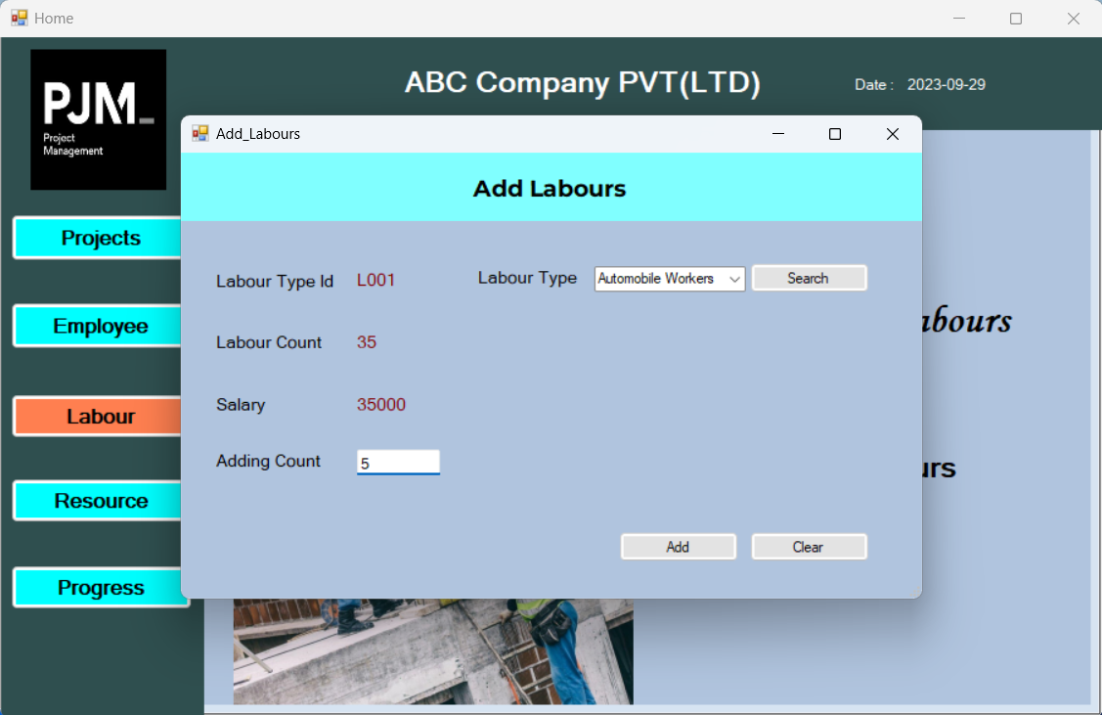

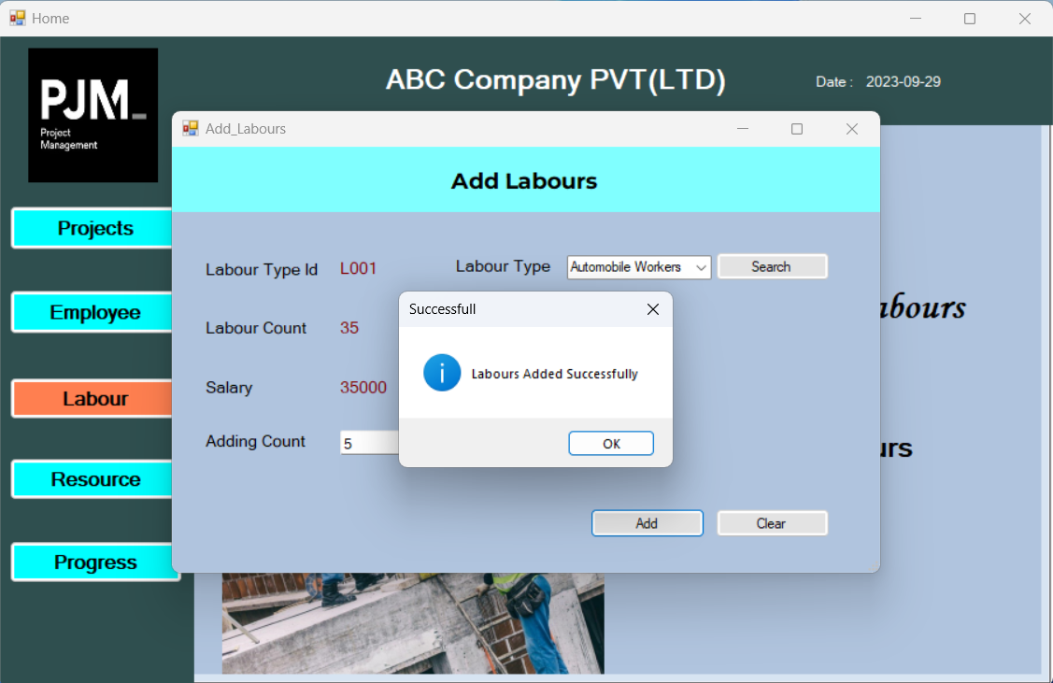

using System;

using System.Collections.Generic;

using System.ComponentModel;

using System.Data;

using System.Data.SqlClient;

using System.Drawing;

using System.Linq;

using System.Runtime.InteropServices.ComTypes;

using System.Text;

using System.Threading.Tasks;

using System.Windows.Forms;

using System.Xml.Linq;

namespace ProjectManagementSystem

{

public partial class Add_Labours : Form

{

public Add_Labours()

{

InitializeComponent();

}

private void Add_Labours_Load(object sender, EventArgs e)

{

if(txtId.Text == "")

{

textCountBox.Visible = false;

}

else

{

textCountBox.Visible = true;

}

SqlConnection conn = new SqlConnection("Data Source=localhost\\SQLEXPRESS;Initial Catalog=PMSDB;Integrated Security=True");

conn.Open();

SqlCommand cmd1 = new SqlCommand("Select LabourType From Labours", conn);

List<string> LabourTypes = new List<string>();

using (SqlDataReader reader1 = cmd1.ExecuteReader())

{

while (reader1.Read())

{

string labourType = reader1["LabourType"].ToString();

LabourTypes.Add(labourType);

}

}

string[] labourTypeArray = LabourTypes.ToArray();

comboBox1.Items.AddRange(labourTypeArray);

conn.Close();

}

private void button3_Click(object sender, EventArgs e)

{

txtId.Text = "";

txtCount.Text = "";

txtSalary.Text = "";

comboBox1.Text = "";

textCountBox.Clear();

}

private void button1_Click(object sender, EventArgs e)

{

SqlConnection conn = new SqlConnection("Data Source=localhost\\SQLEXPRESS;Initial Catalog=PMSDB;Integrated Security=True");

conn.Open();

SqlCommand cmd = new SqlCommand("Select * from Labours where LabourType=@type", conn);

cmd.Parameters.AddWithValue("type", comboBox1.Text);

SqlDataReader reader1;

reader1 = cmd.ExecuteReader();

if (reader1.Read())

{

txtId.Text = reader1["LabourTypeId"].ToString();

txtSalary.Text = reader1["Salary"].ToString();

txtCount.Text = reader1["Count"].ToString();

}

else

{

MessageBox.Show("Invalid Labour Check Again..", "Data Not Found", MessageBoxButtons.OK, MessageBoxIcon.Error);

}

if (txtId.Text == String.Empty)

{

textCountBox.Visible = false;

}

else

{

textCountBox.Visible = true;

}

}

private void button2_Click(object sender, EventArgs e)

{

SqlConnection conn = new SqlConnection("Data Source=localhost\\SQLEXPRESS;Initial Catalog=PMSDB;Integrated Security=True");

conn.Open();

SqlCommand cmd = new SqlCommand("UPDATE Labours SET Count=@Count WHERE LabourTypeId=@id", conn);

cmd.Parameters.AddWithValue("@id", txtId.Text);

cmd.Parameters.AddWithValue("@Count", int.Parse(txtCount.Text) + int.Parse(textCountBox.Text));

cmd.ExecuteNonQuery();

conn.Close();

MessageBox.Show("Labours Added Successfully", "Successfull", MessageBoxButtons.OK, MessageBoxIcon.Information);

txtId.Text = "";

txtCount.Text = "";

txtSalary.Text = "";

comboBox1.Text = "";

textCountBox.Clear();

}

}

}

**==============================================================================**

**Labours Details Form**

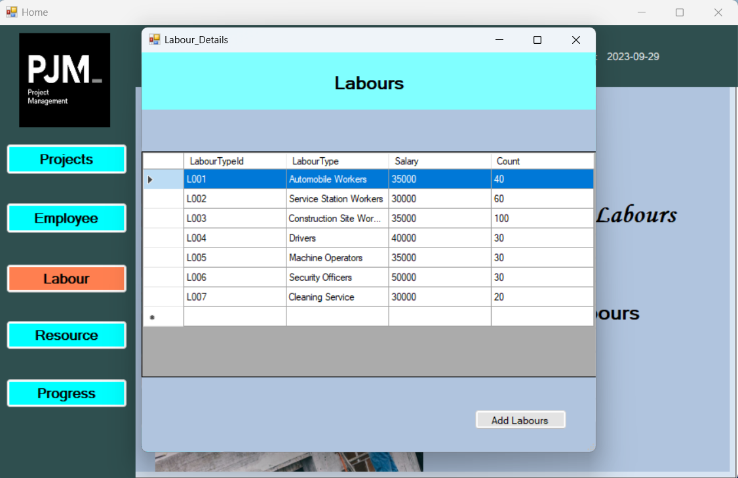

using System;

using System.Collections.Generic;

using System.ComponentModel;

using System.Data;

using System.Drawing;

using System.Linq;

using System.Text;

using System.Threading.Tasks;

using System.Windows.Forms;

namespace ProjectManagementSystem

{

public partial class Labour_Details : Form

{

public Labour_Details()

{

InitializeComponent();

}

private void button1_Click(object sender, EventArgs e)

{

Add_Labours al1 = new Add_Labours();

al1.ShowDialog();

}

private void Labour_Details_Load(object sender, EventArgs e)

{

this.sqlDataAdapter1.Fill(this.laboursSet1.Labours);

}

private void label1_Click(object sender, EventArgs e)

{

}

}

}

**==============================================================================**

**Resource Page**

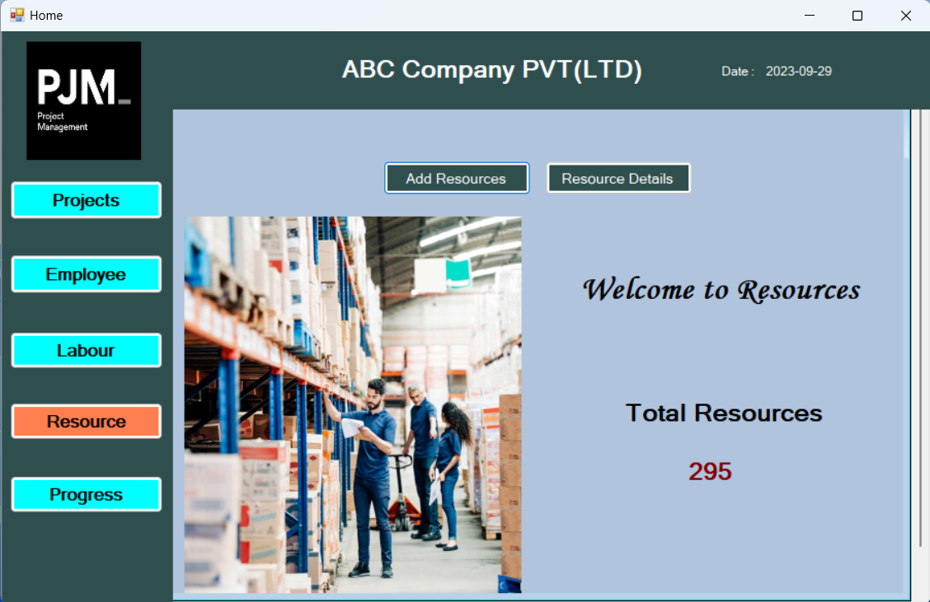

using System;

using System.Collections.Generic;

using System.ComponentModel;

using System.Data;

using System.Data.SqlClient;

using System.Drawing;

using System.Linq;

using System.Text;

using System.Threading.Tasks;

using System.Windows.Forms;

namespace ProjectManagementSystem

{

public partial class Resources : Form

{

public Resources()

{

InitializeComponent();

}

private void button1_Click(object sender, EventArgs e)

{

Add_Resources ar1 = new Add_Resources();

ar1.ShowDialog();

}

private void Resources_Load(object sender, EventArgs e)

{

SqlConnection conn = new SqlConnection("Data Source=localhost\\SQLEXPRESS;Initial Catalog=PMSDB;Integrated Security=True");

conn.Open();

SqlCommand cmd1 = new SqlCommand("Select SUM(Qty) From Resources", conn);

int rsCount = (int)cmd1.ExecuteScalar();

total.Text = rsCount.ToString();

conn.Close();

}

private void button2_Click(object sender, EventArgs e)

{

Resources_Details rd1 = new Resources_Details();

rd1.ShowDialog();

}

}

}

**==============================================================================**

**Add Resources Form**

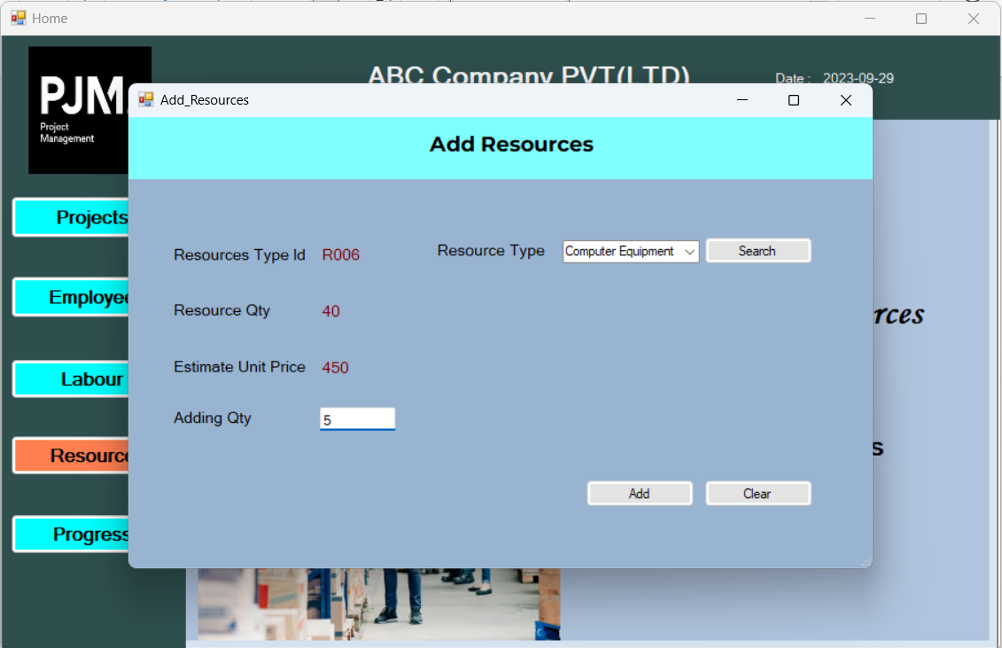

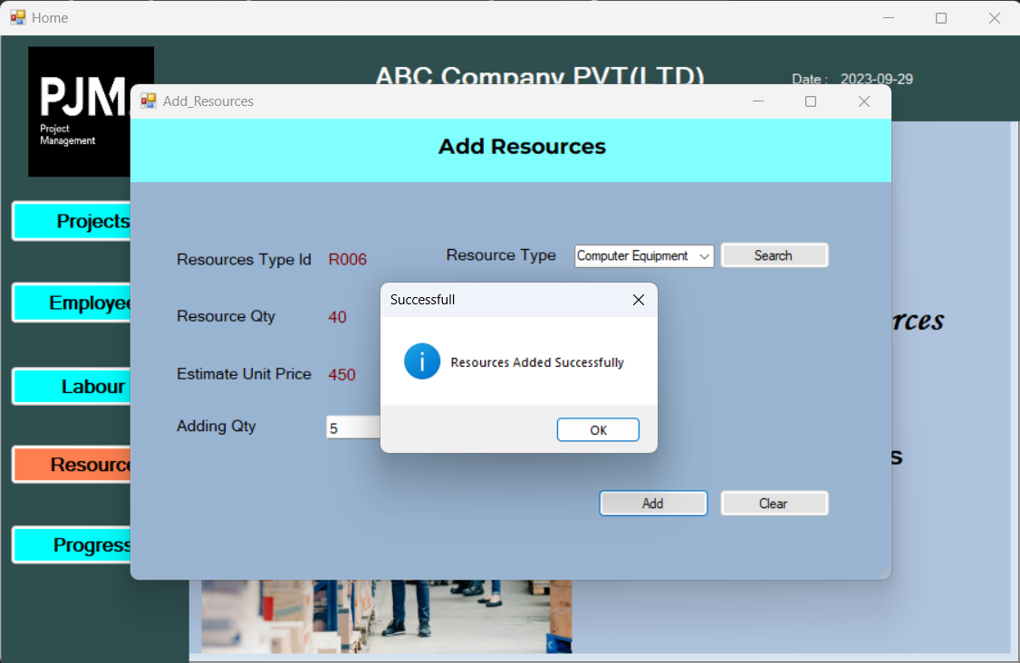

using System;

using System.Collections.Generic;

using System.ComponentModel;

using System.Data;

using System.Data.SqlClient;

using System.Drawing;

using System.Linq;

using System.Text;

using System.Threading.Tasks;

using System.Windows.Forms;

namespace ProjectManagementSystem

{

public partial class Add_Resources : Form

{

public Add_Resources()

{

InitializeComponent();

}

private void Add_Resources_Load(object sender, EventArgs e)

{

if (txtId.Text == "")

{

textCountBox.Visible = false;

}

else

{

textCountBox.Visible = true;

}

SqlConnection conn = new SqlConnection("Data Source=localhost\\SQLEXPRESS;Initial Catalog=PMSDB;Integrated Security=True");

conn.Open();

SqlCommand cmd1 = new SqlCommand("Select ResourceTypeName From Resources", conn);

List<string> ResourceTypes = new List<string>();

using (SqlDataReader reader1 = cmd1.ExecuteReader())

{

while (reader1.Read())

{

string ResourceType = reader1["ResourceTypeName"].ToString();

ResourceTypes.Add(ResourceType);

}

}

string[] ResourceTypeArray = ResourceTypes.ToArray();

comboBox1.Items.AddRange(ResourceTypeArray);

conn.Close();

}

private void button1_Click(object sender, EventArgs e)

{

SqlConnection conn = new SqlConnection("Data Source=localhost\\SQLEXPRESS;Initial Catalog=PMSDB;Integrated Security=True");

conn.Open();

SqlCommand cmd = new SqlCommand("Select * from Resources where ResourceTypeName=@type", conn);

cmd.Parameters.AddWithValue("type", comboBox1.Text);

SqlDataReader reader1;

reader1 = cmd.ExecuteReader();

if (reader1.Read())

{

txtId.Text = reader1["ResourceTypeId"].ToString();

txtPrice.Text = reader1["UnitPrice"].ToString();

txtCount.Text = reader1["Qty"].ToString();

}

else

{

MessageBox.Show("Invalid Resources Check Again..", "Data Not Found", MessageBoxButtons.OK, MessageBoxIcon.Error);

}

if (txtId.Text == String.Empty)

{

textCountBox.Visible = false;

}

else

{

textCountBox.Visible = true;

}

}

private void button2_Click(object sender, EventArgs e)

{

SqlConnection conn = new SqlConnection("Data Source=localhost\\SQLEXPRESS;Initial Catalog=PMSDB;Integrated Security=True");

conn.Open();

SqlCommand cmd = new SqlCommand("UPDATE Resources SET Qty=@Qty WHERE ResourceTypeId=@id", conn);

cmd.Parameters.AddWithValue("@id", txtId.Text);

cmd.Parameters.AddWithValue("@Qty", int.Parse(txtCount.Text) + int.Parse(textCountBox.Text));

cmd.ExecuteNonQuery();

conn.Close();

MessageBox.Show("Labours Added Successfully", "Successfull", MessageBoxButtons.OK, MessageBoxIcon.Information);

txtId.Text = "";

txtCount.Text = "";

txtPrice.Text = "";

comboBox1.Text = "";

textCountBox.Clear();

}

private void button3_Click(object sender, EventArgs e)

{

txtId.Text = "";

txtCount.Text = "";

txtPrice.Text = "";

comboBox1.Text = "";

textCountBox.Clear();

}

}

}

**==============================================================================**

**Resources Details Form**

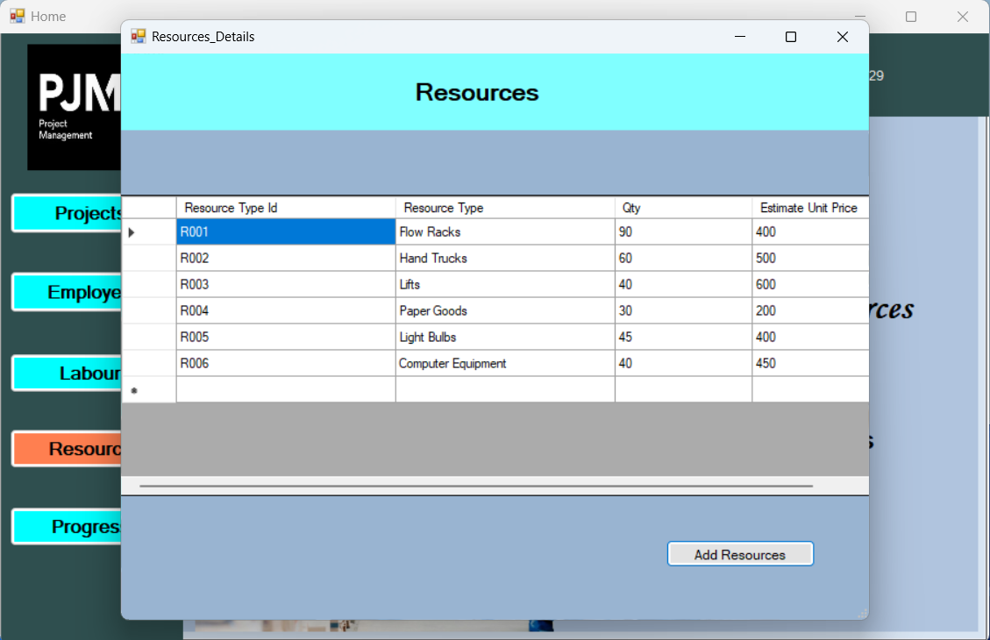

using System;

using System.Collections.Generic;

using System.ComponentModel;

using System.Data;

using System.Drawing;

using System.Linq;

using System.Text;

using System.Threading.Tasks;

using System.Windows.Forms;

namespace ProjectManagementSystem

{

public partial class Resources_Details : Form

{

public Resources_Details()

{

InitializeComponent();

}

private void button1_Click(object sender, EventArgs e)

{

Add_Resources ar1 = new Add_Resources();

ar1.ShowDialog();

}

private void Resources_Details_Load(object sender, EventArgs e)

{

this.sqlDataAdapter1.Fill(this.resourceSet1.Resources);

}

}

}

**==============================================================================**

**Progress Page**

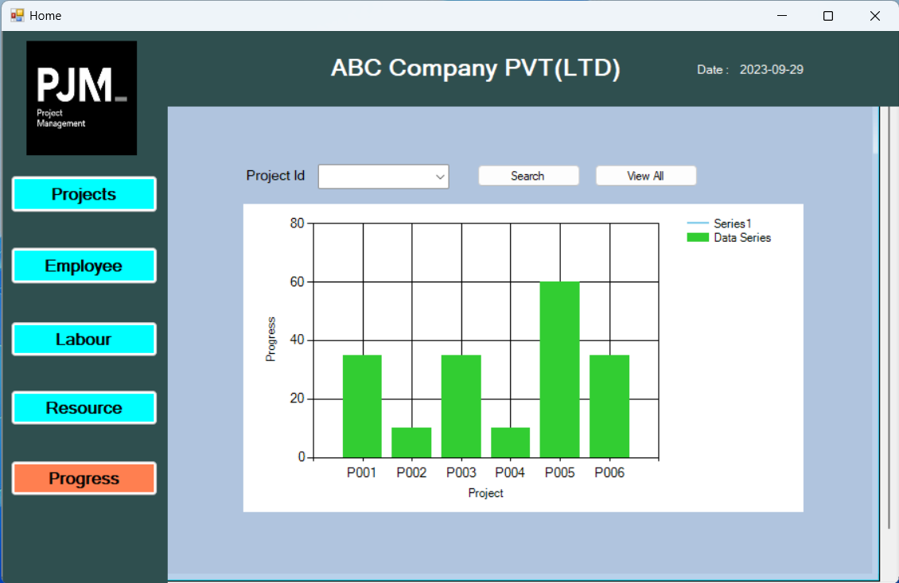

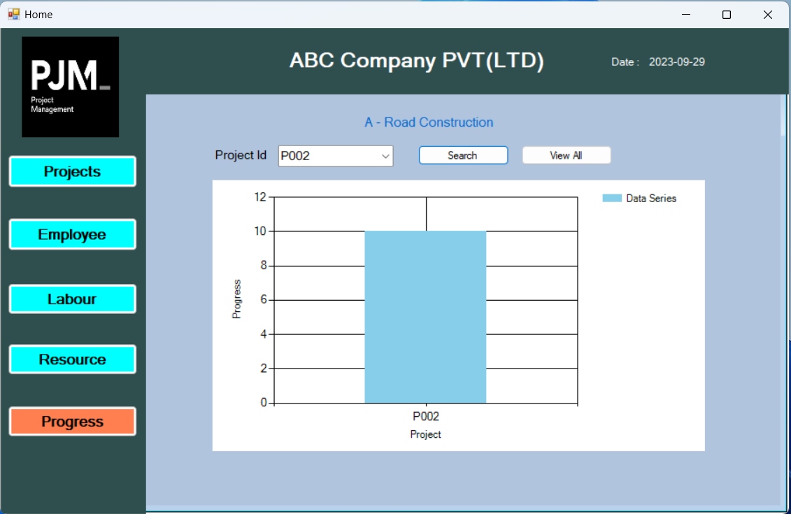

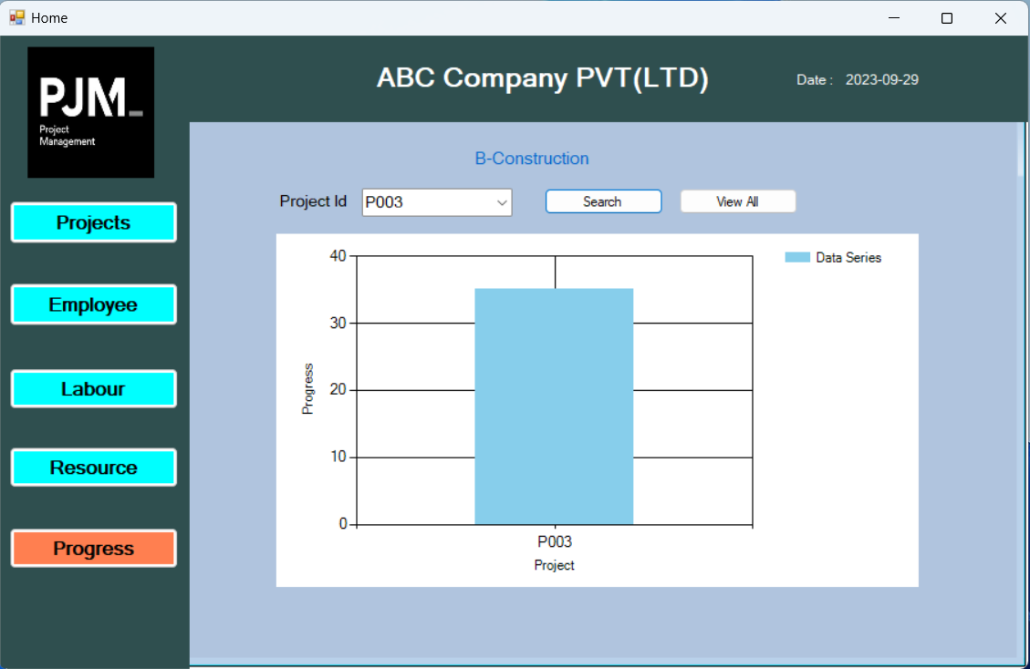

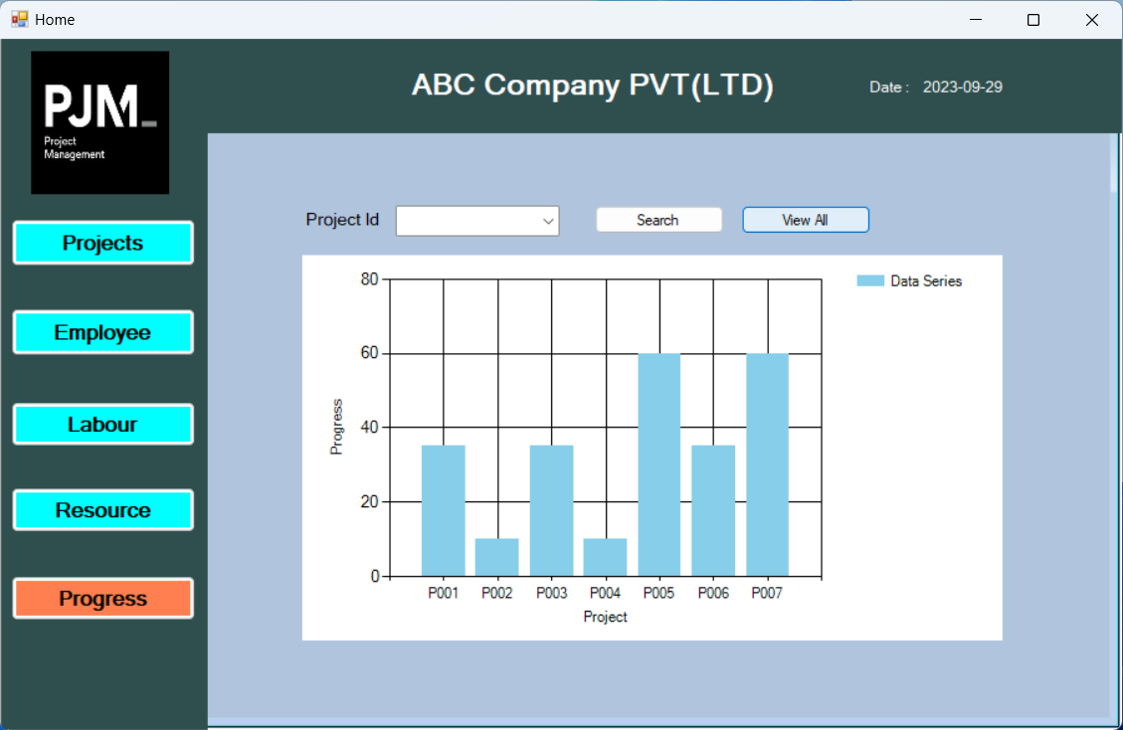

using System;

using System.Collections.Generic;

using System.ComponentModel;

using System.Data;

using System.Data.SqlClient;

using System.Drawing;

using System.Linq;

using System.Text;

using System.Threading.Tasks;

using System.Windows.Forms;

using System.Windows.Forms.DataVisualization.Charting;

using System.Xml.Linq;

using static System.Windows.Forms.AxHost;

using static System.Windows.Forms.VisualStyles.VisualStyleElement;

namespace ProjectManagementSystem

{

public partial class Progress : Form

{

public Progress()

{

InitializeComponent();

}

private void button1_Click(object sender, EventArgs e)

{

Projects p1 = new Projects();

this.Hide();

p1.ShowDialog();

this.Close();

}

private void Progress_Load(object sender, EventArgs e)

{

// Create a series

Series series = new Series("Data Series");

series.ChartType = SeriesChartType.Column;

chart1.Series.Add(series);

// Connect to the database

string connectionString = "Data Source=localhost\\SQLEXPRESS;Initial Catalog=PMSDB;Integrated Security=True";

using (SqlConnection connection = new SqlConnection(connectionString))

{

connection.Open();

SqlCommand cmd = new SqlCommand("SELECT ProjectId, Status FROM Projects", connection);

// Read data from the database and add data points to the series

SqlDataReader reader1 = cmd.ExecuteReader();

while (reader1.Read())

{

string Id = reader1["ProjectId"].ToString();

int value = 0;

switch (reader1["Status"].ToString())

{

case "Planned":

value = 10;

break;

case "Analyzed":

value = 35;

break;

case "Started":

value = 60;

break;

case "Completed":

value = 80;

break;

case "Closed":

value = 100;

break;

// Handle other statuses as needed

}

// Add data points based on the "Name" column value

series.Points.AddXY(Id, value);

// Label the X-axis directly

chart1.ChartAreas[0].AxisX.Title = "Project";

// Label the Y-axis directly

chart1.ChartAreas[0].AxisY.Title = "Progress";

// Refresh the chart to display the changes

chart1.Refresh();

}

reader1.Close();

}

SqlConnection conn = new SqlConnection(connectionString);

conn.Open();

SqlCommand cmd1 = new SqlCommand("Select ProjectId From Projects", conn);

List<string> ProjIds = new List<string>();

using (SqlDataReader reader1 = cmd1.ExecuteReader())

{

while (reader1.Read())

{

string projId = reader1["ProjectId"].ToString(); // Assuming ProjectId is a string

ProjIds.Add(projId);

}

}

// Convert the list to an array if needed

string[] empIdsArray = ProjIds.ToArray();

// Populate a ListBox or another control with the array

comboBox1.Items.AddRange(empIdsArray);

}

private void button2_Click(object sender, EventArgs e)

{

Series series = new Series("Data Series");

series.ChartType = SeriesChartType.Column;

chart1.Series.Clear();

chart1.Series.Add(series);

SqlConnection conn = new SqlConnection("Data Source=localhost\\SQLEXPRESS;Initial Catalog=PMSDB;Integrated Security=True");

conn.Open();

SqlCommand cmd = new SqlCommand("Select ProjectId,Name,Status from Projects where ProjectId=@id", conn);

cmd.Parameters.AddWithValue("id", comboBox1.Text);

SqlDataReader reader1 = cmd.ExecuteReader();

while (reader1.Read())

{

string Id = reader1["ProjectId"].ToString();

ProjName.Text = reader1["Name"].ToString();

int value = 0;

switch (reader1["Status"].ToString())

{

case "Planned":

value = 10;

break;

case "Analyzed":

value = 35;

break;

case "Started":

value = 60;

break;

case "Completed":

value = 80;

break;

case "Closed":

value = 100;

break;

// Handle other statuses as needed

}

// Add data points based on the "Name" column value

series.Points.AddXY(Id, value);

// Label the X-axis directly

chart1.ChartAreas[0].AxisX.Title = "Project";

// Label the Y-axis directly

chart1.ChartAreas[0].AxisY.Title = "Progress";

// Refresh the chart to display the changes

chart1.Refresh();

}

reader1.Close();

}

private void button1_Click_1(object sender, EventArgs e)

{

comboBox1.Text = "";

ProjName.Text = " ";

chart1.Series.Clear();

Series series = new Series("Data Series");

series.ChartType = SeriesChartType.Column;

chart1.Series.Add(series);

// Connect to the database

string connectionString = "Data Source=localhost\\SQLEXPRESS;Initial Catalog=PMSDB;Integrated Security=True";

using (SqlConnection connection = new SqlConnection(connectionString))

{

connection.Open();

SqlCommand cmd = new SqlCommand("SELECT ProjectId, Status FROM Projects", connection);

// Read data from the database and add data points to the series

SqlDataReader reader1 = cmd.ExecuteReader();

while (reader1.Read())

{

string Id = reader1["ProjectId"].ToString();

int value = 0;

switch (reader1["Status"].ToString())

{

case "Planned":

value = 10;

break;

case "Analyzed":

value = 35;

break;

case "Started":

value = 60;

break;

case "Completed":

value = 80;

break;

case "Closed":

value = 100;

break;

// Handle other statuses as needed

}

// Add data points based on the "Name" column value

series.Points.AddXY(Id, value);

// Label the X-axis directly

chart1.ChartAreas[0].AxisX.Title = "Project";

// Label the Y-axis directly

chart1.ChartAreas[0].AxisY.Title = "Progress";

// Refresh the chart to display the changes

chart1.Refresh();

}

reader1.Close();

}

}

}

}

**=================== Screenshots & Code implementation end … ==================**

**Demo video of our project**

**Click me**

https://drive.google.com/file/d/1Bty0FCPX91jddkMx1wVGunjNbm2dikQo/view?usp=sharing